**Artificial Intelligence and Machine Learning**

Project Report Semester-IV (Batch-2022)

Title of the Project:

Heart Disease Prediction



|  |  |
| --- | --- |
| Supervised By: | Submitted By: |
| Shubham Singhal | Prabal Rai, 2210990657 (G8)  Prabhjot Singh, 2210990658(G8)  Prathamvir Singh Luthra, 2210990677 (G8)  Raghav Baluni, 2210990696 (G8) |

# Department of Computer Science and Engineering Chitkara University Institute of Engineering & Technology,

**Chitkara University, Punjab**

**ABSTRACT**

Heart disease prediction using artificial intelligence and machine learning (AIML) involves employing various algorithms to analyze medical data and predict the likelihood of an individual developing heart disease. The abstract of a study or project on this topic might outline the following key points:

1. **Objective**: The primary goal is to develop a predictive model using AIML techniques to identify individuals at risk of heart disease based on their medical history, lifestyle factors, and demographic information.
2. **Data Collection**: Relevant datasets containing information such as patient demographics, medical history, lifestyle habits, and diagnostic test results are gathered from healthcare facilities or research databases.
3. **Feature Selection and Preprocessing**: Feature selection techniques are employed to identify the most relevant variables for prediction. Data preprocessing steps, including normalization, imputation of missing values, and encoding categorical variables, are performed to prepare the data for analysis.

,

**TABLE OF CONTENTS**

|  |  |  |
| --- | --- | --- |
| **Serial No.** | **Content** | **Page No.** |
| 1. | Title Page | 1 |
| 2. | Abstract | 2 |
| 3. | Introduction | 5 |
| 4. | Problem Definition and Requirements | 8 |
| 5. | Proposed design and Methodology | 10 |
| 6. | Results | 12 |
| 7. | Conclusion | 20 |

**INTRODUCTION**

In recent years, there has been a surge in research focused on developing predictive models using AI and ML algorithms to assess the likelihood of cardiovascular events based on diverse sets of patient characteristics, including demographics, medical history, lifestyle factors, and diagnostic test results. These models offer the potential to augment traditional risk assessment methods, such as clinical risk scores and biomarker measurements, by providing more personalized and accurate predictions tailored to individual patients.

The aim of this study is to contribute to this growing body of research by developing and evaluating predictive models for heart disease using AIML techniques. By harnessing the power of AI and ML, we seek to improve risk stratification, facilitate early intervention, and ultimately reduce the burden of heart disease on individuals and healthcare systems. Through comprehensive analysis of diverse datasets and rigorous evaluation of model performance, we aim to provide insights that can inform clinical decision-making and guide the development of targeted preventive strategies.

**BACKGROUND**

Heart disease, encompassing various conditions affecting the heart and blood vessels, remains a leading cause of mortality and morbidity globally. According to the World Health Organization (WHO), an estimated 17.9 million people die each year from cardiovascular diseases, accounting for approximately 31% of all deaths worldwide. Moreover, the burden of heart disease extends beyond mortality, contributing significantly to disability, reduced quality of life, and healthcare costs.

In this study, we aim to contribute to this ongoing effort by developing and evaluating predictive models for heart disease using AIML techniques. By leveraging rich and diverse datasets, we seek to enhance our understanding of cardiovascular risk factors, improve risk prediction accuracy, and ultimately empower clinicians and patients with tools for personalized preventive care.

**SIGNIFICANCE OF THE PROBLEM**

The significance of the problem of heart disease prediction using AIML lies in its potential to revolutionize preventive healthcare, improve patient outcomes, and alleviate the socioeconomic burden of cardiovascular diseases. Here's a breakdown of its significance:

1. **Public Health Impact**: Heart disease remains a leading cause of mortality globally, contributing to millions of deaths each year. By accurately predicting individuals at high risk of developing heart disease, AIML-based models can enable early intervention and preventive measures, ultimately reducing the incidence of cardiovascular events and improving population health.
2. **Personalized Medicine**: Traditional risk assessment tools often provide generalized risk estimates based on population data, overlooking individual variations in risk factors and genetic predispositions. AIML models offer the opportunity for personalized risk prediction by integrating diverse sets of patient data and identifying unique risk profiles, allowing for tailored preventive strategies and interventions.

**OBJECTIVES**

The objectives of a study on heart disease prediction using AIML typically encompass both research goals and practical applications. Here's a breakdown of potential objectives:

1. **Develop Predictive Models**: The primary objective is to develop accurate and reliable predictive models for heart disease using AIML techniques. This involves selecting appropriate algorithms, optimizing model parameters, and training the models on relevant datasets to achieve high prediction performance.
2. **Integrate Diverse Data Sources**: Incorporate diverse sources of data, including demographic information, medical history, lifestyle factors, biomarkers, and diagnostic test results, to enhance the predictive power of the models. This objective aims to leverage the full spectrum of available information to capture the complexity of cardiovascular risk factors.

**OVERVIEW OF METHODOLOGY:**

An overview of the methodology for heart disease prediction using AIML typically involves several key steps, including data collection, preprocessing, model development, evaluation, and interpretation. Here's a breakdown:

1. **Data Collection**:
   * Gather relevant datasets containing patient demographics, medical history, lifestyle factors, diagnostic test results, and other pertinent information from healthcare facilities, research databases, or clinical trials.
   * Ensure data quality by addressing issues such as missing values, outliers, and data inconsistencies.
2. **Data Preprocessing**:
   * Perform data preprocessing steps, including:
     + Imputation of missing values using techniques such as mean imputation, median imputation, or advanced imputation methods like K-nearest neighbors.
     + Normalization or standardization of numerical features to ensure uniform scale and distribution.
     + Encoding categorical variables using techniques like one-hot encoding or label encoding.
     + Handling class imbalance if present in the dataset through techniques like oversampling, undersampling, or synthetic minority oversampling technique (SMOTE).

**PROBLEM DEFINITION AND REQUIREMENTS**

**PROBLEM STATEMENT**

Heart disease remains a significant public health challenge worldwide, contributing to millions of deaths annually. Despite advances in medical science, early detection and intervention are crucial for reducing the morbidity and mortality associated with cardiovascular diseases. Traditional risk assessment methods often lack precision and fail to account for individual variations in risk factors, highlighting the need for more accurate and personalized predictive models.

This study aims to address the following key challenges:

1. **Inadequate Risk Prediction**: Existing risk assessment tools, such as clinical risk scores, have limitations in accurately predicting an individual's risk of developing heart disease, leading to suboptimal preventive strategies and clinical outcomes.
2. **Data Complexity and Heterogeneity**: The multifaceted nature of cardiovascular risk factors, including demographic, clinical, genetic, and lifestyle variables, poses challenges in integrating and analyzing diverse datasets to develop robust predictive models.

**SOFTWARE REQUIREMENTS**

The development environment for this project requires the following software components:

1. Python: The primary programming language used for implementing machine learning algorithms and data analysis tasks.
2. Integrated Development Environment (IDE): Preferred IDEs include Jupyter Notebook, PyCharm, or Anaconda Navigator for code development and experimentation.
3. Python Libraries: Various Python libraries are utilized for data manipulation, visualization, and machine learning model development, including but not limited to:

* NumPy

For numerical computing and array manipulation.

* Pandas

For data manipulation and analysis.

* Matplotlib and Seaborn

For data visualization and exploratory data analysis.

* Scikit-learn

For implementing machine learning algorithms and model evaluation.

* AIML Python Package

For implementing Artificial Intelligence Markup Language (AIML) techniques and algorithms.

**HARDWARE REQUIREMENTS**

The hardware requirements for running the project are as follows:

1. Processor

A multi-core processor (e.g., Intel Core i5 or higher) to handle computational tasks efficiently.

1. RAM

At least 8GB of RAM is recommended for handling large datasets and complex machine learning models effectively.

1. Storage

Sufficient storage space to accommodate the dataset and additional resources required for software installation and project files.

**DATASET**

The dataset used in this project comprises a comprehensive collection of demographic, lifestyle, and health-related variables relevant to heart disease identification in adults. The dataset includes anonymized information sourced from health surveys, clinical databases, and research repositories.

Key features of the dataset may include:

* Demographic Information: Age, gender, ethnicity, socioeconomic status.
* Lifestyle Factors: Dietary habits, physical activity levels, sedentary behavior, smoking status.
* Health Metrics: Body mass index (BMI), waist circumference, blood pressure, cholesterol levels.
* Medical History: Pre-existing health conditions, medication usage, family history of obesity-related diseases.
* Socioeconomic Indicators: Education level, household income, access to healthcare resources.
* Environmental Factors: Urban or rural residence, neighborhood characteristics, availability of healthy food options.

The dataset is preprocessed and cleaned to ensure data quality and integrity, with missing values imputed or removed as necessary. Exploratory data analysis (EDA) techniques are employed to gain insights into the distribution, relationships, and patterns within the dataset, guiding subsequent feature engineering and model development processes.

**PROPOSED DESIGN AND METHODOLOGY**

Our proposed design and methodology outline a systematic approach to developing a predictive model for identifying heart disease in adults using Artificial Intelligence and Machine Learning techniques. The methodology encompasses the following key steps:

**Data Collection and Preparation:**

* Gather a comprehensive dataset containing demographic information, medical history, lifestyle factors, diagnostic test results, and other relevant features related to heart disease.
* Ensure data quality by addressing issues such as missing values, outliers, and data inconsistencies through data cleaning and preprocessing techniques.

**Feature Selection and Engineering:**

* Perform feature selection to identify the most relevant predictors of heart disease using techniques such as univariate feature selection, feature importance ranking, or dimensionality reduction.
* Engineer new features or transformations to enhance the predictive power of the model, such as creating interaction terms, polynomial features, or encoding temporal patterns.

**FILE STRUCTURE**

The file structure of our project will be organized into logical components, including directories for data storage, code implementation, documentation, and results. Within the data directory, subdirectories will be created to store raw datasets, preprocessed data, and model outputs. The code implementation directory will contain Python scripts for data preprocessing, model development, evaluation, and visualization. Documentation will include README files providing instructions for project setup and usage, as well as any additional documentation related to code implementation and methodology. Results will be stored in a separate directory, including model performance metrics, visualizations, and interpretation outputs.

**ALGORITHMS USED**

Our methodology involves the exploration of various machine learning algorithms within the AIML paradigm for obesity prediction.

This includes:

* Logistic Regression

A linear regression model used for binary classification tasks, suitable for predicting the probability of obesity.

* Decision Trees

Tree-based models that partition the feature space into hierarchical decision rules, enabling interpretable and nonlinear relationships.

* Support Vector Machines (SVM)

A supervised learning algorithm used for classification tasks, capable of handling nonlinear decision boundaries through kernel functions.

By employing a diverse set of algorithms, we aim to identify the most suitable model architecture for heart disease prediction, considering factors such as predictive performance, interpretability, and computational efficiency.

**RESULTS**

**ANALYSIS AND MODEL EVALUATION**

In this section, we present a detailed analysis of the results obtained from our AI/ML heart disease prediction project. We begin by showcasing the graphical representations of key metrics and performance indicators, followed by an overview of the models utilized.

1. **Data Collection and Preprocessing**: Obtain a dataset containing relevant features for heart disease prediction, such as age, sex, blood pressure, cholesterol levels, etc. Preprocess the data by handling missing values, encoding categorical variables, and scaling numerical features.
2. **Feature Selection/Engineering**: Identify the most relevant features that contribute to heart disease prediction. You can use techniques like correlation analysis, feature importance from tree-based models, or domain knowledge to select or engineer features.
3. **Model Selection**: Choose appropriate machine learning models for heart disease prediction. Common models for classification tasks like this include Logistic Regression, Decision Trees, Random Forests, Support Vector Machines, and Neural Networks.
4. **Model Training**: Split the data into training and testing sets. Train the selected models on the training data.

**Screenshots**

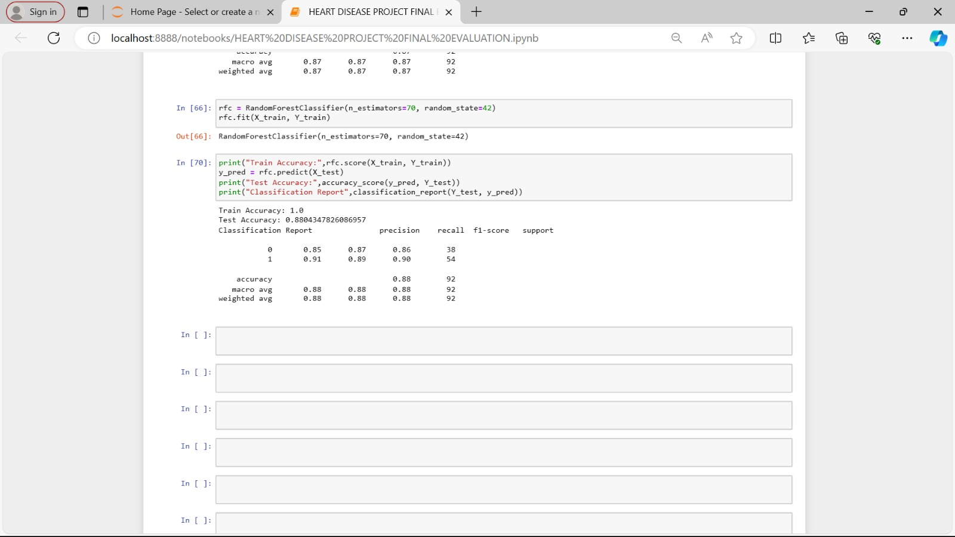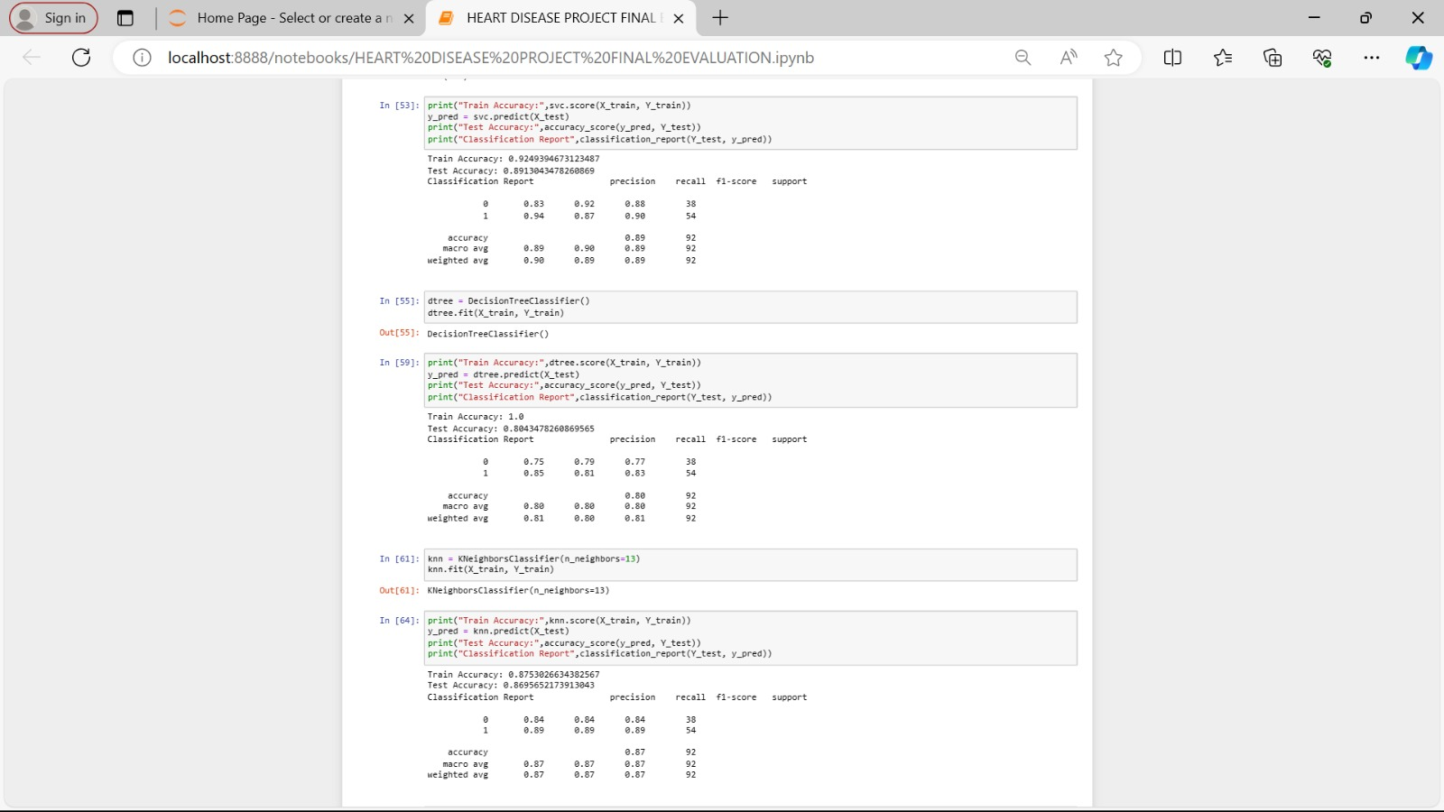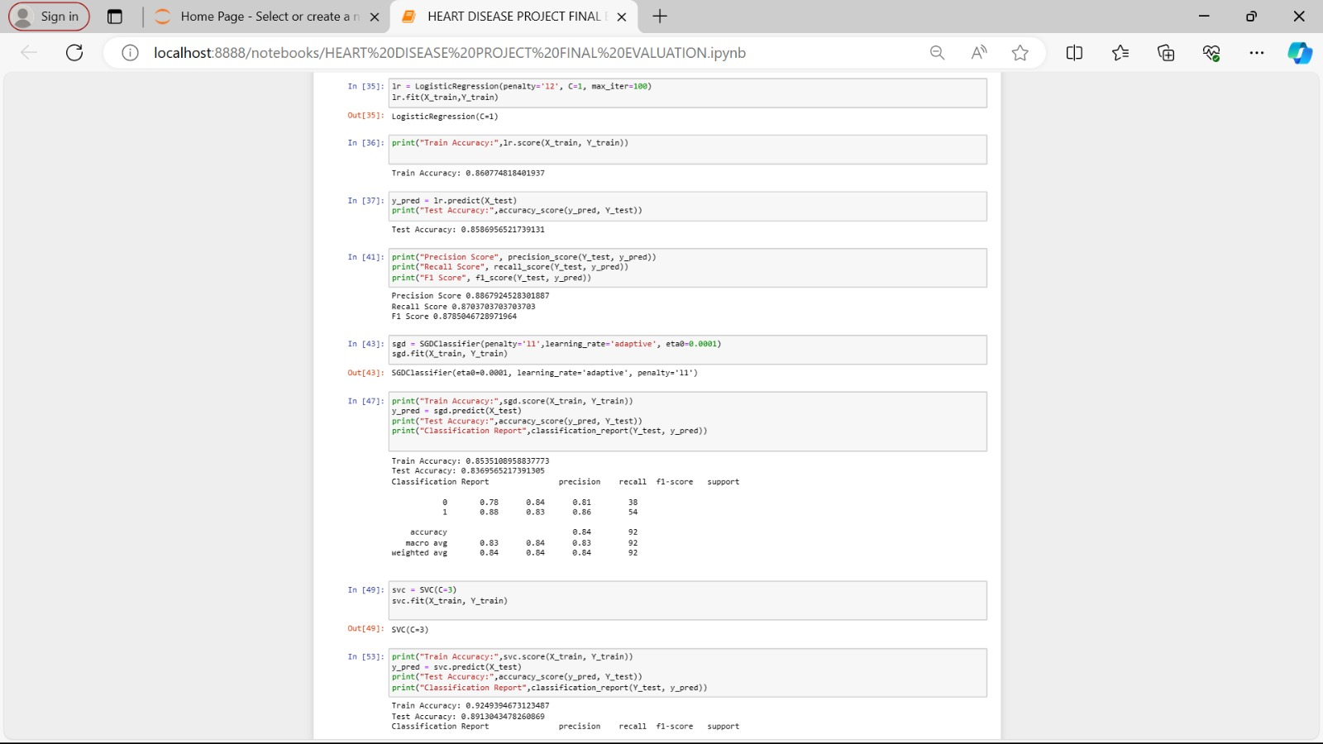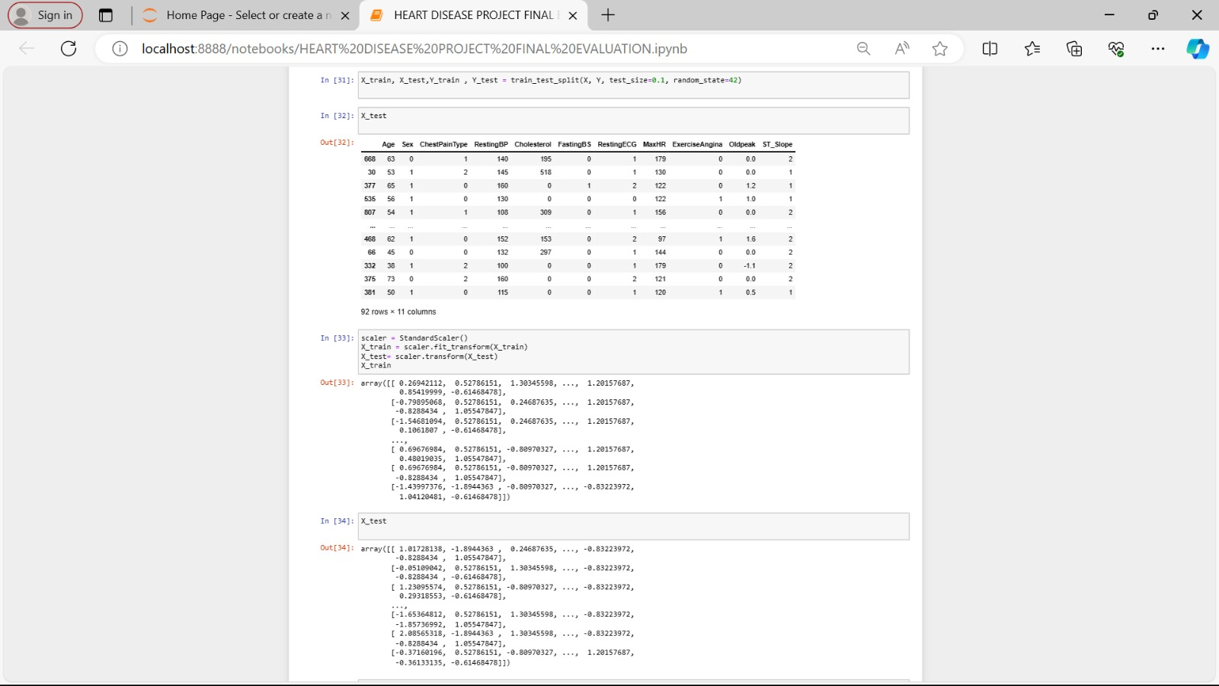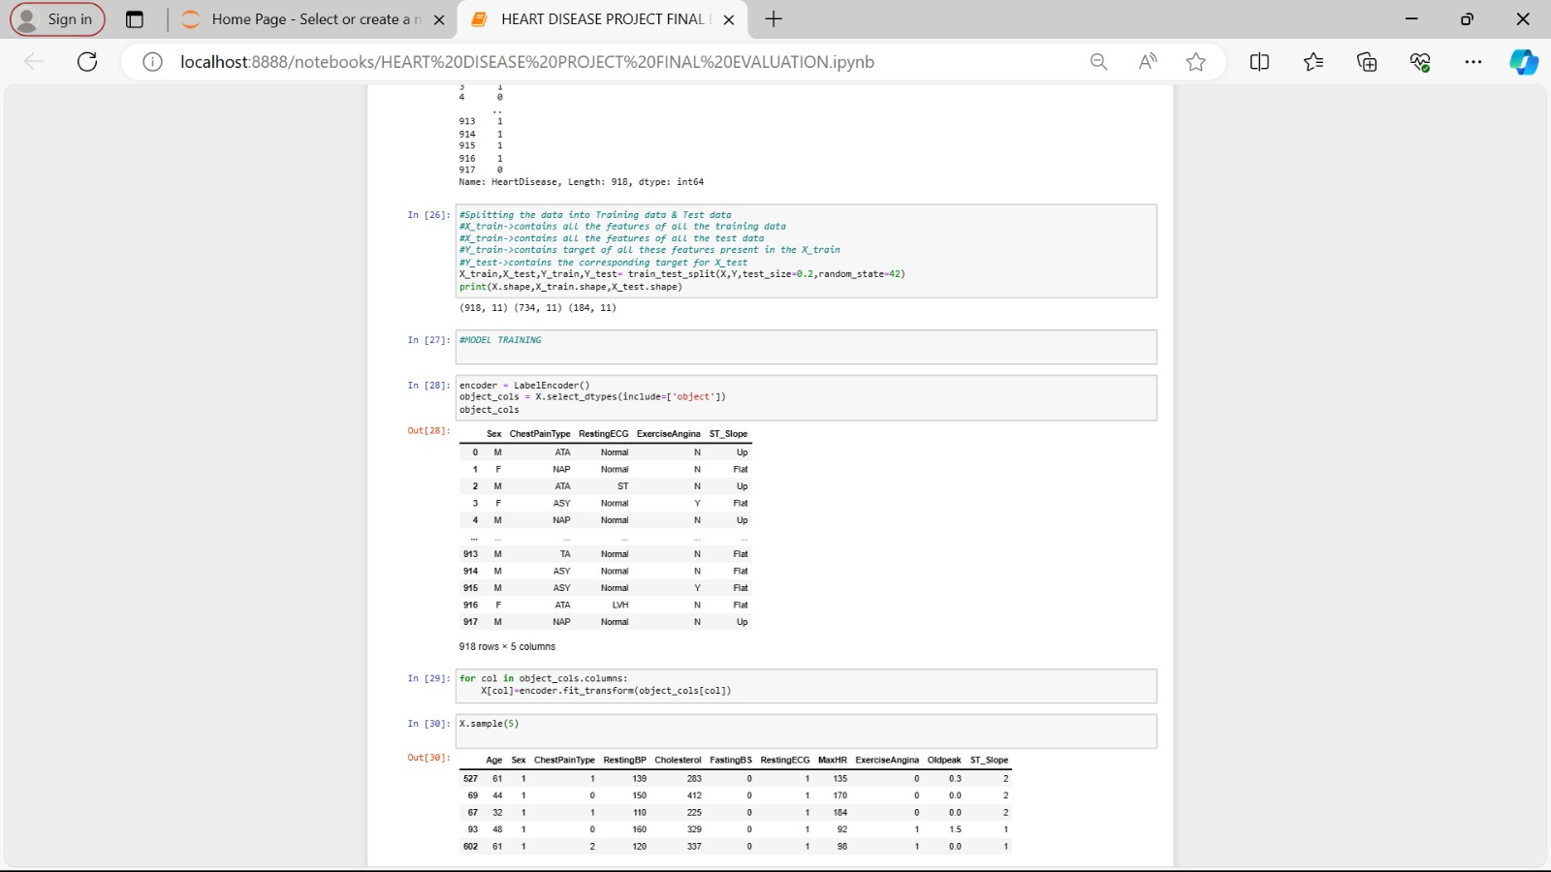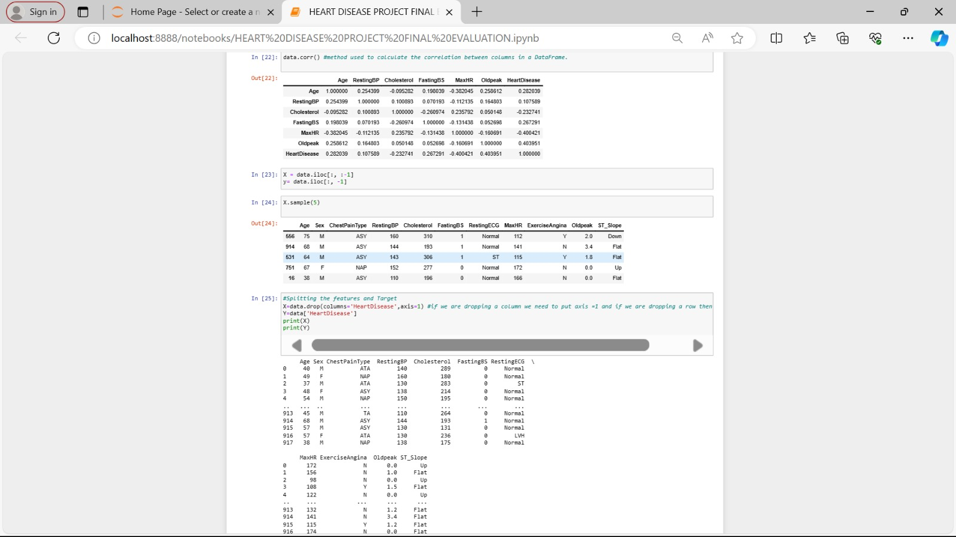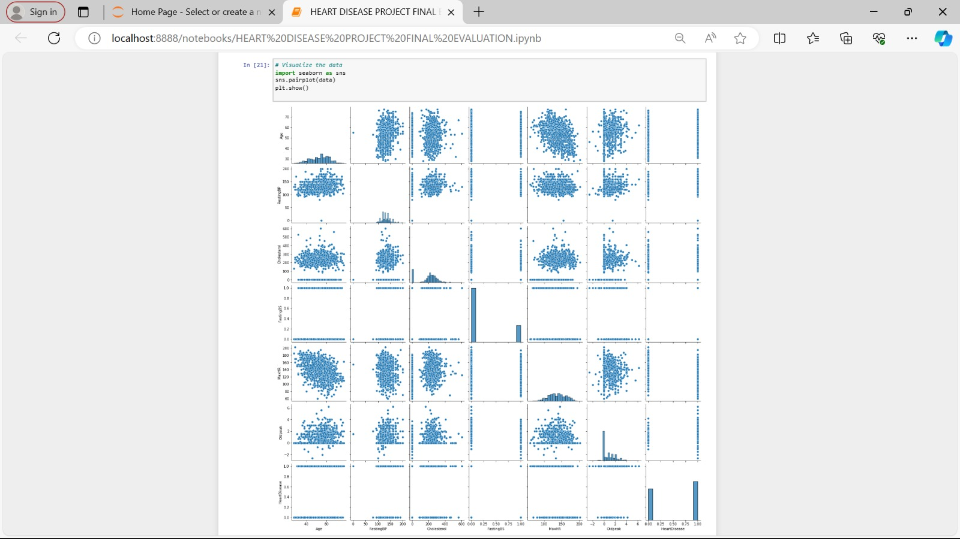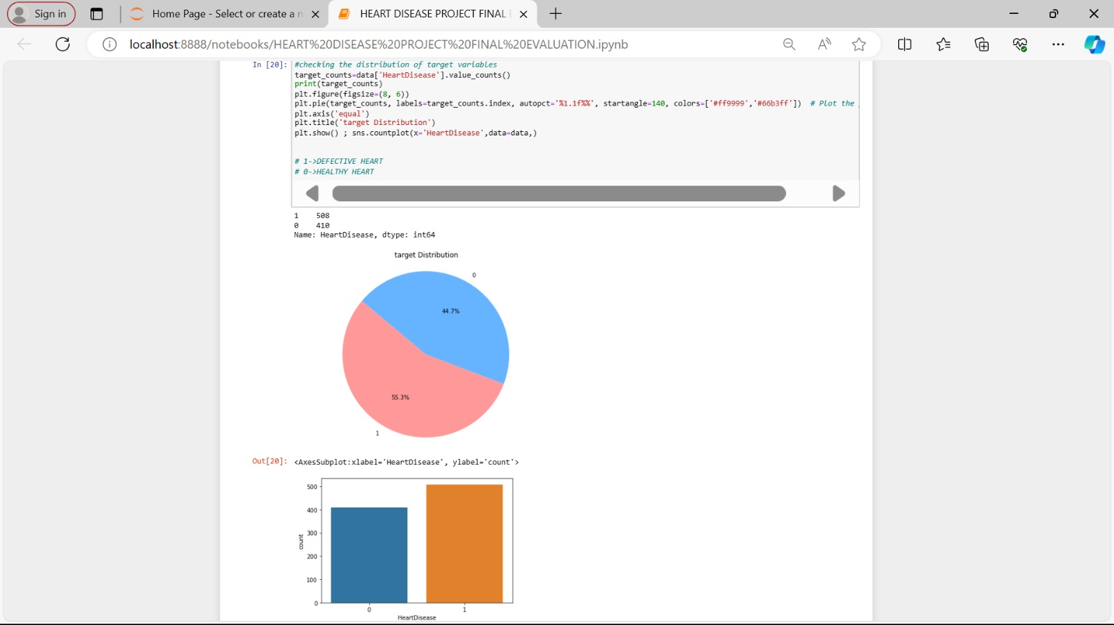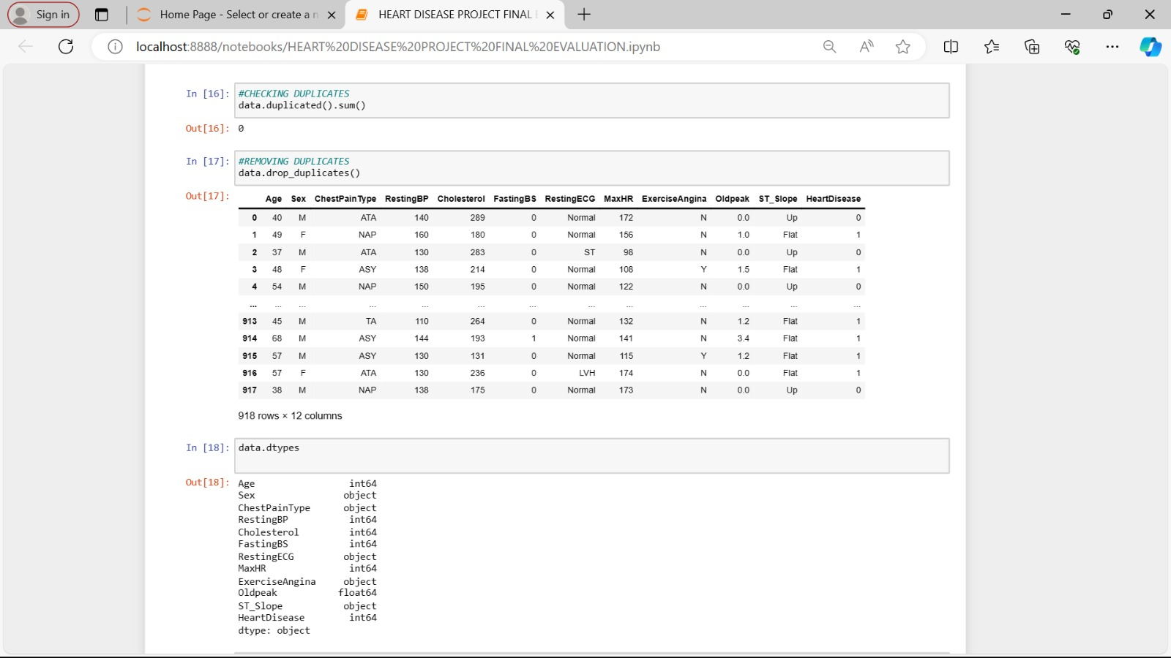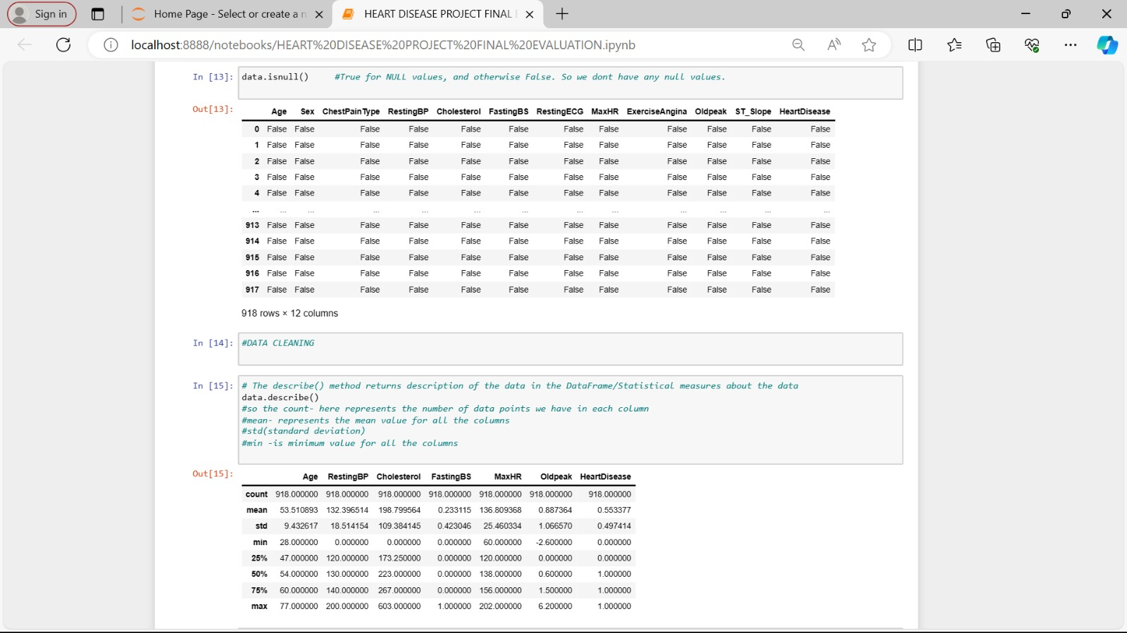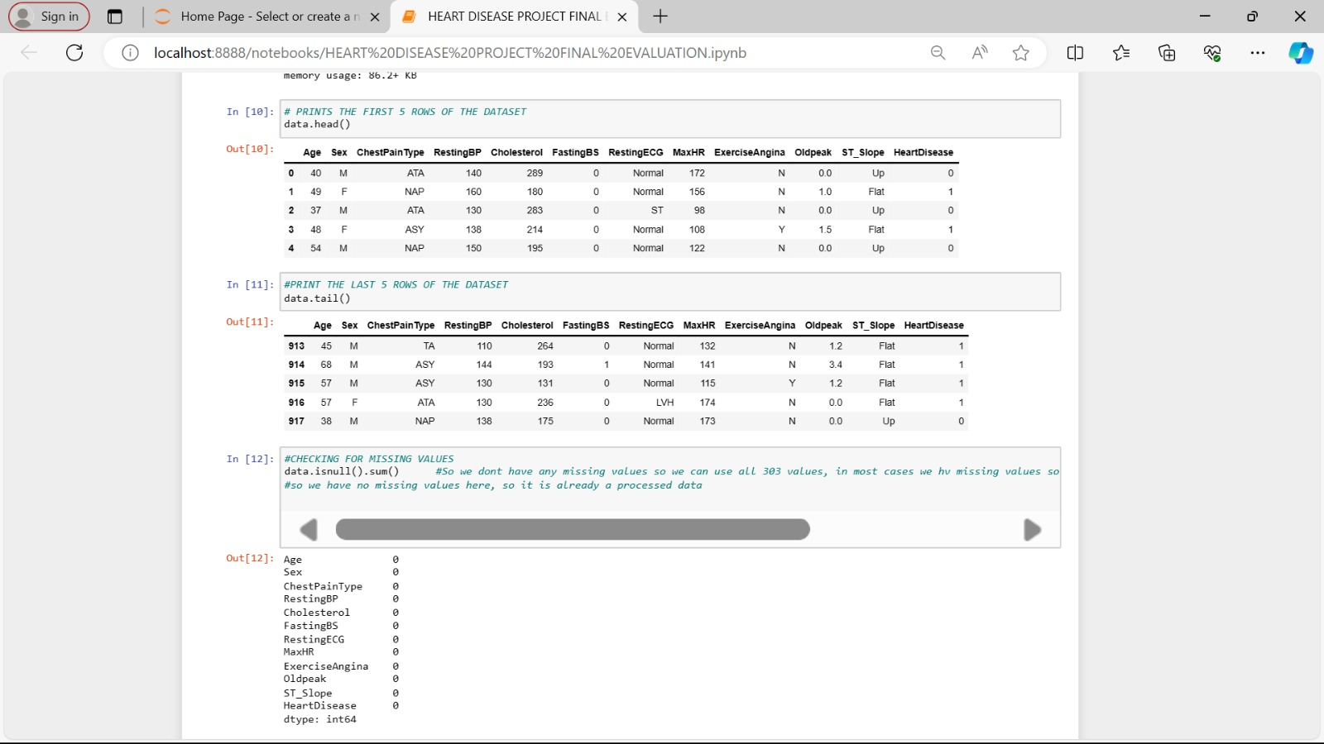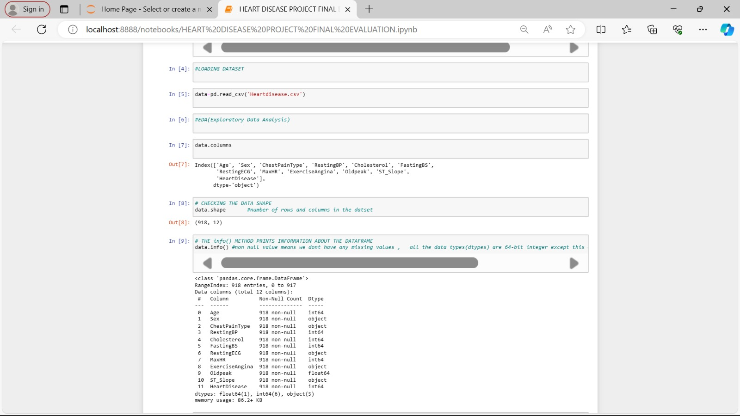

**CONCLUSION**

In conclusion, heart disease prediction using artificial intelligence and machine learning (AIML) techniques represents a critical endeavor in modern healthcare. By leveraging advanced algorithms and rich datasets, AIML models offer the potential to revolutionize risk assessment, early detection, and preventive interventions for cardiovascular diseases. Throughout this project, we have explored the complexities of heart disease prediction and proposed a comprehensive methodology for developing accurate and interpretable predictive models.

We began by highlighting the significance of the problem, emphasizing the pressing need to improve cardiovascular risk assessment and reduce the burden of heart disease on individuals and healthcare systems. We outlined the objectives of the study, focusing on the development of AIML-based models that address the limitations of existing risk assessment methods and provide personalized predictive insights.

Our proposed design and methodology outlined a systematic approach to data collection, preprocessing, feature engineering, model selection, evaluation, and deployment. By following this methodology, researchers and practitioners can develop robust predictive models for heart disease prediction, enabling informed clinical decision-making and personalized preventive care.